CDG Stage 1 Test
1. System Configuration

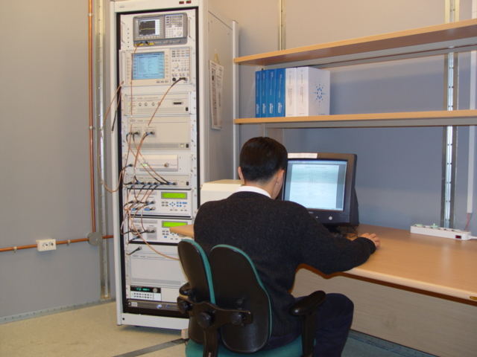
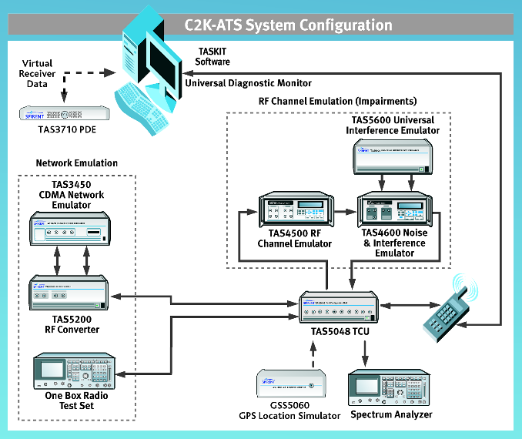
Figure 1. System Configuration

The C2K-ATS (CDMA 2000-Automatic Test System) provides an integrated test solution for evaluating parametric performance and signaling conformance of CDMA mobile devices. By combining SR 5500 RF Channel Emulator, TAS 5600 Noise & Interference Emulator, and Air Access C2K (TAS3450 and TAS5200) with a base station emulator (E5515C) and the other essential CDMA test equipments, a turn-key test system is used. TASKIT/C2K Windows software automates mobile testing by configuring the instruments, stepping through the test sequences, and logging the results.

Table 1. Component and Function
Component | Function
① Agilent E4404B | System calibration, System diagnostics, and Transmitter measurements of the mobile station.
② Agilent 8960 | Base Station Emulator
③ TAS 3450 | Providing multiple sectors for true soft, softer and hard handoff emulation.
④ TAS 5200
⑤ GSS 5060 | AFLT/A-GPS/GPS/Hybrid Position Location Test
⑥ TAS 5048 | Switching of RF connections
⑦ TAS 5068 | Switching of RF connections
⑧ SR 5500 | Multi Path Fading Emulator
⑨ TAS 5600 | Dual tone CW generator
⑩ Agilent 6630B | DC Power Source
⑪ TAS 3710 | AFLT/A-GPS/GPS/Hybrid Position Location Test

2. Service

- Development Confirmation testing
- CTIA/CCF Certification testing
- TRAC A Certification testing
- Performance Quality testing for domestic mobile phones

3. Test Coverage

Table 2. Test Coverage (C.S0011)
C.S0011 | Recommended Minimum Performance Standards for cdma2000 Spread Spectrum Mobile Stations | TTA Coverage
3 | CDMA RECEIVER MINIMUM STANDARDS
3.1 | Frequency Coverage Requirements
3.2 | Acquisition Requirements
3.2.1 | Idle Handoff Tests
3.2.1.1 | Idle Handoff in non-Slotted Mode on the Paging Channel | feasible
3.2.1.2 | Idle Handoff in Slotted Mode on the Paging Channel | feasible
3.2.1.3 | Idle Handoff in Slotted Mode on the Forward Common Control Channel
3.2.1.4 | Idle Handoff to Another Frequency
3.2.2 | Soft Handoff Tests
3.2.2.1 | Neighbor Set Pilot Detection and Incorrect Detection in Soft Handoff | feasible
3.2.2.2 | Candidate Set Pilot Detection and Incorrect Detection in Soft Handoff | feasible
3.2.2.3 | Active Set Pilot Loss Detection in Soft Handoff | feasible
3.2.3 | Access and Access Probe Handoff Tests
3.2.3.1 | Access Probe Handoff
3.2.3.2 | Access Handoff
3.2.4 | Candidate Frequency Single Search | feasible
3.3 | Forward Common Channel Demodulation Performance
3.3.1 | Demodulation of non-Slotted Mode Paging Channel | feasible
3.3.2 | Demodulation of Slotted Mode Paging Channel | feasible
3.3.3 | Demodulation of Broadcast Control Channel in AWGN Channel
3.3.4 | Demodulation of Broadcast Control Channel in Multipath Fading Channel
3.3.5 | Demodulation of Forward Common Control Channel
3.3.6 | Demodulation of Common Assignment Channel and Reception of Common Power Control Channel
3.4 | Forward Traffic Channel Demodulation Performance
3.4.1 | Demodulation of Forward Traffic Channel in Additive White Gaussian Noise | feasible
3.4.2 | Demodulation of Forward Traffic Channel in Multipath Fading Channel | feasible
3.4.3 | Demodulation of Forward Traffic Channel During Soft Handoff | feasible
3.4.4 | Decision of Power Control Bit for Channels Belonging to Different Power Control Sets During Soft Handoff | feasible
3.4.5 | Decision of Power Control Bit for Channels Belonging to the Same Power Control Set | feasible
3.4.6 | Demodulation of Power Control Subchannel During Soft Handoff
3.4.7 | Demodulation of Forward Traffic Channel in Multipath Fading Channel with Closed Loop Power Control (FPC_MODE='000') | feasible
3.4.8 | Demodulation of Forward Traffic Channel in Multipath Fading Channel with Closed Loop Power Control (FPC_MODE='010')
3.4.9 | Demodulation of Forward Traffic Channel in Multipath Fading Channel with Outer Loop Power Control and Closed Loop Power Control (FPC_MODE='000', '001' and '010') | feasible
3.4.10 | Demodulation of Forward Traffic Channel in Multipath Fading Channel with Closed Loop Power Control (FPC_MODE='000') and Transmit Diversity (OTD or STS)
3.4.11 | Demodulation of Forward Traffic Channel in Multipath Fading Channel with Closed Loop Power Control (FPC_MODE='010') and Transmit Diversity (OTD or STS)
3.4.12 | Demodulation of Power Control Subchannel During Reverse Pilot Channel Gating
3.4.13 | Demodulation of Power Control Subchannel During Reverse Fundamental Channel Gating
3.5 | Receiver Performance
3.5.1 | Receiver Sensitivity and Dynamic Range | feasible
3.5.2 | Single Tone Desensitization | feasible
3.5.3 | Intermodulation Spurious Response Attenuation | feasible
3.5.4 | Adjacent Channel Selectivity
3.5.5 | Receiver Blocking Characteristics
3.6 | Limitations on Emissions
3.6.1 | (Rx) Conducted Spurious Emissions | feasible
3.6.2 | (Rx) Radiated Spurious Emissions
3.7 | Supervision
3.7.1 | Paging Channel | feasible
3.7.2 | Forward Traffic Channel
4 | CDMA TRANSMITTER MINIMUM STANDARDS
4.1 | Frequency Accuracy | feasible
4.2 | Handoff
4.2.1 | CDMA to CDMA Hard Handoff | feasible
4.2.2 | Transmit Power After Hard Handoff | feasible
4.3 | Modulation Requirements
4.3.1 | Time Reference | feasible
4.3.2 | Reverse Pilot Channel to Code Channel Time Tolerance | feasible
4.3.3 | Reverse Pilot Channel to Code Channel Phase Tolerance | feasible
4.3.4 | Waveform Quality and Frequency Accuracy | feasible
4.3.5 | Code Domain Power | feasible
4.4 | RF Output Power Requirements
4.4.1 | Range of Open Loop Output Power | feasible
4.4.2 | Time Response of Open Loop Power Control | feasible
4.4.3 | Access Probe Output Power | feasible
4.4.4 | Range of Closed Loop Power Control | feasible
4.4.5 | Maximum RF Output Power | feasible
4.4.6 | Minimum Controlled Output Power | feasible
4.4.7 | Standby Output Power and Gated Output Power | feasible
4.4.8 | Power Up Function Output Power
4.4.9.2.1 | Code Channel Output Power for the Enhanced Access Channel Header, Enhanced Access Channel Data, and Reverse Common Control Channel Data
4.4.9.2.2 | Code Channel Output Power for the Reverse Traffic Channel | feasible
4.4.10 | Reverse Pilot Channel Transmit Phase Discontinuity
4.4.11 | Reverse Traffic Channel Output Power During Changes in Data Rate
4.5 | Limitations on Emissions
4.5.1 | (TX) Conducted Spurious Emissions | feasible
4.5.2 | (TX) Radiated Spurious Emissions
4.5.3 | Occupied Bandwidth
5 | Environmental Requirements
5.1 | Temperature and Power Supply Voltage | feasible
5.2 | High Humidity | feasible
5.3 | Vibration Stability | feasible
5.4 | Shock Stability | feasible

Table. Test Coverage (C.S0033)
C.S0033 | Recommended Minimum Performance Standards for cdma2000 High Rate Packet Data Access Terminal | TTA Coverage
3.1.1.1 | Frequency Coverage Requirements
3.1.1.2.1 | Demodulation of Forward Traffic Channel in AWGN | feasible
3.1.1.2.2 | Demodulation of Forward Traffic Channel in Multi-path Fading Channel | feasible
3.1.1.2.3 | Decision of Power Control Bit for Channels belonging to Different Power Control Sets during Soft Handoff | feasible
3.1.1.2.4 | Decision of Power Control Bit for Channels belonging to the Same Power Control Set | feasible
3.1.1.2.5 | Demodulation of Reverse Power Control Channel during Soft Handoff
3.1.1.3.1 | Receiver Sensitivity and Dynamic Range | feasible
3.1.1.3.2 | Single Tone Desensitization | feasible
3.1.1.3.3 | Intermodulation Spurious Response Attenuation | feasible
3.1.1.3.4 | Adjacent Channel Selectivity
3.1.1.3.5 | Receiver Blocking Characteristics
 | Limitations on Emissions
3.1.1.4.1 | Conducted Spurious Emissions | feasible
3.1.1.4.2 | Radiated Spurious Emissions
 | Transmitter Minimum Standards
3.1.2.1.1 | Frequency Coverage
3.1.2.1.2 | Frequency Accuracy | feasible
 | Modulation Requirements
3.1.2.2.1 | Time Reference | feasible
3.1.2.2.2 | Waveform Quality and Frequency Accuracy | feasible
3.1.2.2.3 | Redundant ACK Transmission
 | RF Output Power Requirements
3.1.2.3.1 | Range of Open Loop Output Power | feasible
3.1.2.3.2 | Time Response of Open Loop Power Control | feasible
3.1.2.3.3 | Range of Closed Loop Power Control | feasible
3.1.2.3.4 | Maximum RF Output Power | feasible
3.1.2.3.5 | Minimum Controlled Output Power | feasible
3.1.2.3.6 | Standby Output Power | feasible
3.1.2.3.7 | RRI Channel Output Power | feasible
 | Code Domain Power
3.1.2.3.8.1 | DRC Channel Output Power | feasible
3.1.2.3.8.2 | ACK Channel Output Power | feasible
3.1.2.3.8.3 | Data Channel Output Power | feasible
 | Limitations on Emissions
3.1.2.4.1 | Conducted Spurious Emissions | feasible
 | Occupied Bandwidth
3.1.2.4.3 | Occupied Bandwidth
 | MAC Layer Minimum Standards
4.1.1.1 | Control Channel Supervision
 | Forward Traffic Channel MAC Protocol
4.2.1.1 | Data Rate Control Performance
4.2.1.2 | Demodulation of Forward Traffic Channel during Soft Handoff
4.2.1.3 | Supervision Procedures in Variable Rate State
 | Access Channel MAC Protocol
4.3.1.1 | Access Probes Output Power | feasible
 | Reverse Traffic Channel MAC Protocol
4.4.1.1 | Reverse Traffic Channel Initial Transmit Power
4.4.1.2 | Reverse Traffic Channel Transmit Power
4.4.1.3 | Demodulation of the Reverse Activity Channel
4.4.1.4 | Reverse Traffic Channel MAC rate transition probabilities
 | Key Exchange Protocol
5.1.1.1 | Key Signature Computation time
 | Idle State
6.1.1.1.1 | Idle Handoff in Continuous Operation Mode
6.1.1.1.2 | Idle Handoff in Slotted Operation Mode
6.1.1.1.3 | Idle Handoff in Suspended Operation Mode
 | Connected State
6.1.1.2.1 | Neighbor Set Pilot Detection and Incorrect Detection in Soft Handoff
6.1.1.2.2 | Candidate Set Pilot Detection and Incorrect Detection in Soft Handoff
6.1.1.2.3 | Active Set Pilot Loss Detection in Soft Handoff
6.1.1.2.4 | Hard Handoff to another Frequency
 | Environmental Requirements
10.1 | Temperature and Power Supply Voltage | feasible
10.2 | High Humidity | feasible
10.3 | Vibration Stability | feasible
10.4 | Shock Stability | feasible

