CRTU-G for GSM/GPRS Protocol Testing

1. System Configuration
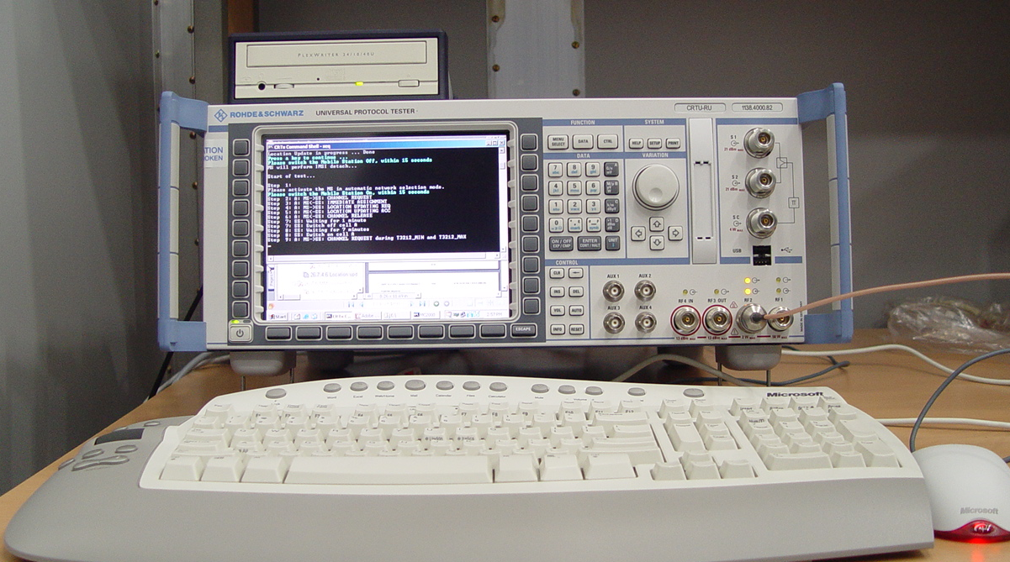
Fig. 1 Rohde & Schwarz CRTU-G

CRTU-G simulates a GSM base station and records all messages sent to and received from a mobile station. This allows detailed analysis of the protocol stack in the mobile station. Protocol stack functions can also be modified the user.

2. Test Coverage
- 3GPP TS 51.010-1
  - Section 11 : General tests
  - Section 16 : Reception Time Tracking Speed(TBD)
  - Section 19 : Channel Release after Unrecoverable Errors
  - Section 25 : GSM Layer 2
  - Section 26 : GSM Layer 3
  - Section 28 : Autocalling Restrictions
  - Section 29 : Bearer Services
  - Section 31 : Supplementary Services
  - Section 34 : Short Message Service
  - Section 41 : GPRS Paging, TBF Establishment/Release and DCCH related Procedures
  - Section 42 : GPRS Medium Access Control
  - Section 43 : GPRS Radio Link Control
  - Section 44 : GPRS Mobility Management
  - Section 45 : GPRS Session Management Procedures
  - Section 46 : GPRS LLC and SNDCP

