CRTU-MMS Testing

1. System Configuration
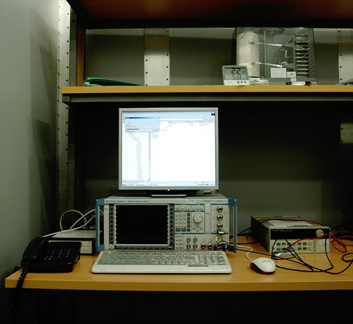
Fig. 1 Rohde & Schwarz CRTU-MMS

TTA facilitates Rohde & Schwarz CRTU-ATE MMS testing platform. CRTU-ATE testing platform uses CRTU-G for its signaling unit. On the CRTU-G protocol testing system, only some software packages are installed for MMS testing extension.

2. Test Coverage
MMS conformance and interoperability test specification is OMA-IOP-MMS-ETS-V1_X, “Enabler Test Specification for MMS 1.X”. The test specification describes the definition, conformance and interoperability requirement, test purpose, method of test, and test requirement.

