CRTU-RRM for WCDMA RRM Testing

1. System Configuration
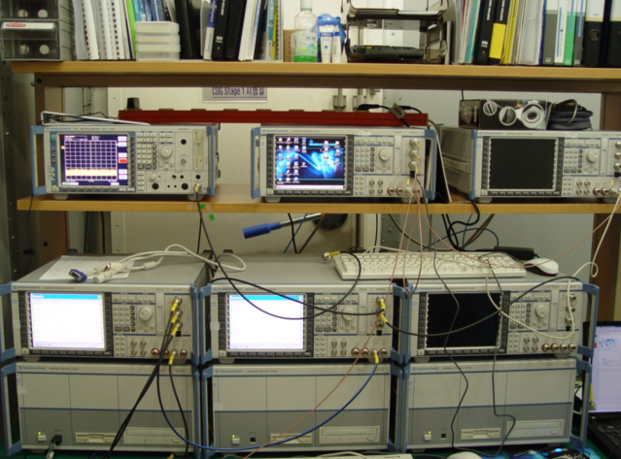
Fig. 1 Rohde & Schwarz CRTU-RRM

WCDMA RRM tester CRTU-RRM is capable of simulating, testing and analyzing WCDMA RRM test cases at the radio interface (Uu). Depending on the specific test application, the CRTU-W/M consists of several components.
2. Test Coverage
- 3GPP TS 34.121-1
  - Section 8 : Requirements for support of RRM

