CRTU-W for WCDMA Protocol Testing

1. System Configuration
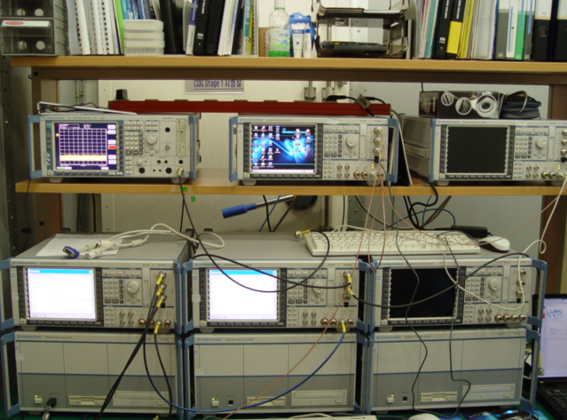
Fig. 1 Rohde & Schwarz CRTU-W

WCDMA protocol tester CRTU-W is capable of simulating, testing and analyzing WCDMA protocols at the radio interface (Uu). Depending on the specific test application, the CRTU-W/M consists of several components.
2. Test Coverage
- 3GPP TS 34.123-1
  - Section 6 : Idle mode
  - Section 7 : Layer 2
  - Section 8 : RRC (Radio Resource Control)
  - Section 9 : MM (Mobility Management)
  - Section 10 : CC (Call Control)
  - Section 11 : SM (Session Management)
  - Section 12 : GMM(GPRS Mobility Management)
  - Section 13 : General Tests
  - Section 14 : Radio Bearer Services
  - Section 16 : SMS (Short Message Service)

