

IPv6 Performance Tests for 1st Multi-sites Remote IPv6 Interoperability Test Event

ETSI/IPv6 Forum
12-14 May 2003

Michael Lynge

Spirent Communications

www.spirentcom.com/ipv6

Version 1.2


Revision History

Revision | Date | Description | Author (Organization)
V1.0 | 5 May 2003 | Document creation | Michael Lynge (Spirent)
V1.1 | 8 May 2003 | Contact Updates | Angus Robertson (Spirent)
V1.2 | 9 May 2003 | Contact Updates | Olivier Vaugrenard (Spirent)

1 Introduction 1
2 Purpose 2
3 Equipment 2
4 Contacts 2
5 Tests 3
5.1 Architecture 3
5.1.1 Local Test 3
5.1.2 Remote Test 3
5.2 Methodology 4
5.2.1 Throughput 4
5.2.2 Packet Loss 4
5.2.3 Latency 4
5.3 Parameters 4
5.4 Throughput Steps 5
5.5 Packet Loss and Latency Steps 5
5.6 Recorded Results 5
6 Summary 6
7 Appendix A – Minimum Frame Size 7
8 Appendix B – Sample Results 7

Introduction

From May 12-14, the Madrid Global IPv6 Summit 2003 and the ETSI Plugtests Interoperability Service will hold a “Multi-sites remote IPv6 interoperability event.” This event is the first multi-site IPv6 event combining the efforts of several organizations for the promotion and testing of IPv6. To help in this effort, it has been proposed that testing be expanded to include Performance testing.

This document provides the framework for creating performance tests. The tests described in this document focus on Throughput, Packet Loss and Latency. These tests are defined by RFCs 1242 and 2544.

Each site will perform the tests as a Local entity and then conduct them with as many Remote sites as possible. Results will then be used to compare against other sites and as a benchmark in future tests.

The amount of traffic proposed for the tests are not intended to stress the system but merely to provide a common baseline of what an end user can expect today.

Purpose

The reasons for adding performance tests are:
      - Determine basic performance characteristics
        - Site Network – From end user to site WAN link
        - Infrastructure Network – Impact of WAN

      - Provide education to Internet community
        - Available test tools – What is available and how they work
        - Performance Testing – How to test
        - Expectations – What to expect from IPv6

      - Increase visibility of IPv6 activities
        - IPv6 in general – Help provide examples for other individuals to follow
  - University/Organizations – Promote groups advancing IPv6 deployment

      - Establish groundwork for future tests

Equipment

The equipment for the tests described in this document has been provided by Spirent Communications to many of the sites participating in the ETSI/IPv6 Forum event. Most sites will have either an AX (Adtech) or SMB (SmartBits) chassis. Each site will have access to the latest IPv6 test tools available with support from the local Spirent teams.

Information about the Spirent’s IPv6 solutions can be found at www.spirentcom.com/ipv6. Information concerning Spirent’s test programs can be found at www.testedwithspirent.com.

Contacts

Site | Country | Contact | Email | Spirent Contact | Email | Time Zone
Madrid GIS 2003 | Madrid, Spain | Cesar Olvera  Jordi Palet | cesar.olvera@consulintel.es  jordi.palet@consulintel.es | Olivier Vaugrenard  Carlos Huidobro (Aspidcom) | olivier.vaugrenard@spirentcom.com  chuidobro@aspidcom.com | GMT  +1
ETSI | Nice, France | Patrick Guillemin  Philippe Cousin | patrick.guillemin@etsi.org  philippe.cousin@etsi.org  sebastien.flaux@etsi.org | Bruno Riou | bruno.riou@spirentcom.com | GMT  +1
UNH | US | Ben Schultz  Fanny Xu | Schultz@io.iol.unh.edu  fx@iol.unh.edu | Bob Anderson | bob.anderson@spirentcom.com | GMT  -5
TTA | Korea | Dong-Hyun Seok  Jongjin Sung | fall@tta.or.kr  jsung@tta.or.kr | Gary Wong | gary.wong@spirentcom.com | GMT  +9
TAHI | Japan | Hiroshi Miyata | H.Miyata@jp.yokogawa.com | Satoru Ajiki (Toyo)  Allen Umeda | ajiki@ict.toyo.co.jp  allen.Umeda@spirentcom.com | GMT  +9
Chung Hwa Telecom Labs/NICI IPv6 | Tapei  Taiwan | Chin-Chou Chen  Chih-Cheng Tsao | chinchou@cht.com.tw  atsao@cht.com.tw | Vic Chen (Paralink) | zycomcph@ms34.hinet.net | GMT  +8

Tests

Since this is the 1st multi-site IPv6 Performance event, testing will focus on the basic tests of Throughput, Packet Loss and Latency. The intention is not to stress test the network/system but to characterize how it is implemented today and use the results as reference for future performance tests. Each site can perform additional tests as time permits.

Since some traffic may inadvertently cross “live” networks, load will be kept to 10 Mbps from only one stream source to one destination.

Architecture

There will be two types of testing: Local and Remote. Both types simulate traffic from a single IPv6 source transmitting data from an end user network connection to a device located on another network across the IPv6 backbone. The only difference between Local and Remote testing is that traffic from Local tests never leaves the site while traffic from Remote tests cross the IPv6 infrastructure.

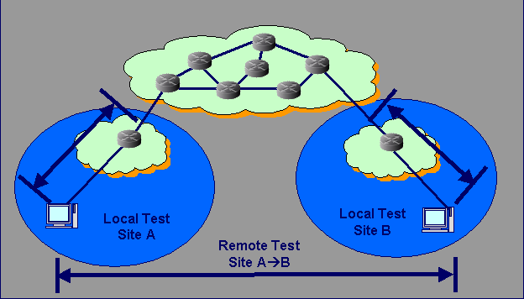

Local Test
Traffic should be injected into the network from where an end-user would normally access (10/100 interface) and then analyzed on the WAN side before being sent out on the WAN/backbone. There should not be any traffic on the network/system being tested or traffic on other ports of devices used in the test. If this is unavoidable, documentation of the other traffic should be recorded since it may impact results.

Remote Test
Remote testing uses the same methodology as Local testing, but the difference is that traffic will be generated from one site’s user access to the remote user access over the WAN. Since generating traffic over the backbone can potentially impact performance of devices that are used in production networks, the path of the traffic needs to be determined before testing begins and every party involved be notified.

Methodology

The test methodology used will adhere to RFCs 1242 and 2544 (www.ietf.org). The specific tests will focus on measuring Throughput, Packet Loss and Latency.
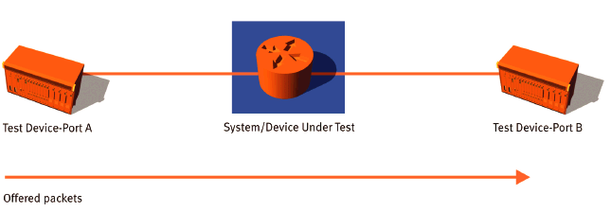

Throughput
The throughput of a device or system is the maximum packet-forwarding rate for which the device or system will not drop any of the offered packets. Any packet loss can induce significant delays in the execution of higher layer applications; thus, knowing the maximum data rate a device or system can support without any packet loss is of crucial importance when judging the performance of a router or system of interconnected routers.

Packet Loss
The packet loss rate of a device or system is the percentage of Layer 3 frames that were offered at the input of the device or system but were not forwarded by the device or system due to hardware and software limitations. Calculating the packet loss rate of a system under different load conditions (input data rate and packet size) serves to evaluate how the system will perform under similar conditions in real-life operation.

Latency
Latency is the amount of time it takes from the transmission of a packet to its receipt. Each test packet is tracked on a packet-by-packet basis.

Latency = (Receive Timestamp) - (Transmit Timestamp)
Note: For Remote testing, Latency measurements should be ignored unless both sites have GPS equipment to synchronize timestamps.

Parameters

IPv6 Stream Setup: Minimum: Single stream (1 port → 1 port)
(Optional Advance Testing: Multi-port (X ports → 1 port))
Max Load: 10 Mbps
Load Steps: 10%, 20%, …, 100%
Packet Sizes*: 128, 256, 512, 1024, 1280, 1518

* See Appendix

Throughput Steps
1. Configure the DUT/SUT so the traffic offered from source port(s) will be forwarded to the destination port(s). This can be accomplished via a routing protocol or statically configured routes.
2. Configure the test parameters:
a. Initial packet rate
b. Packet size
c. Resolution rate for the binary search
d. Latency test run time
3. Send packets from source port(s). It is recommended to start with the maximum packet rate supported by the test port(s). Measure the number of packets transmitted at the source port(s) and the number of packets received at the destination port(s).
4. If no packet loss occurs, the throughput rate is equal to the offered data rate. Stop the test.
5. If packet loss occurs, decrease the packet rate and repeat the test.
6. Continue the binary search algorithm until the maximum packet rate with no packet loss is calculated (throughput rate).
7. Send a packet stream at the calculated throughput rate and measure the latency for the specified duration of time.

Packet Loss and Latency Steps
1. Configure the DUT/SUT so the traffic offered from the source port(s)is forwarded to the destination port(s). This can be accomplished via a routing protocol or statically configured routes.
2. Configure the test parameters:
a. Initial packet rate
b. Packet size
c. Resolution by which the input data rate is decremented
d. Run time for every trial
3. Send packets from source port(s). It is recommended to start with the maximum packet rate supported by the test port(s); measure the number of packets transmitted at the source port(s) and the number of packets received at the destination port(s).
4. If no packet loss occurs in two successive trials, stop the test.
5. If packet loss occurs, calculate the packet loss rate and the latency.
6. Decrement the input data rate and repeat test.
7. The test stops when no packet loss is recorded in two successive trials, or when the input data rate reaches a user-selected threshold.

Recorded Results
For both Local and Remote Tests, the information in the following table should be recorded per test iteration. The test metrics that are affected by each test are denoted with an “X”.

Appendix B has an example of a test with these measurements.

Summary

With Throughput, Packet Loss and Latency tests at both a Local and Remote level, users can gain a better understanding of how IPv6 has been implemented. This information will be important in analyzing the impact of improvements and changes as IPv6 continues to grow.

These tests will also provide a good foundation to include other IPv6 performance tests in the future such as:

      - Dual Stack (IPv4 and IPv6)
      - Tunneling (Automatic and Configured)
      - Translation (IPv4→IPv6, IPv6→IPv4)
      - Routing (RIPng, BGP+, IS-ISv6, OSPFv3)
      - MPLS
      - PPPoX

Appendix A – Minimum Frame Size
Every packet generated has embedded a “signature tag” which contains information concerning: Chassis number, Module number, Stream number, Sequence number, Transmit time and Receive time. The signature tag for SmartBits is 18 bytes and considering everything that makes up an IPv6 packet the minimum is 76 Bytes. Therefore it is recommended that the minimum packet size used is 128 bytes.

Ethernet header: 14
IPv6 header: 40
Signature Tag: 18
CRC: 4
===
Total 76 min frame size

Note: It is possible to generate Jumbo packets.

Appendix B – Sample Results
Tests will follow the procedure of

- Select Load (10%, 20%, …, 100%)
- Run each packet size (128, 256, …, 1518)
- Record results, increase load rerun packet sizes

Example:
Test #1.1: Packet size = 128 byte, Load % = 10%
Test #1.2: Packet size = 128 byte, Load % = 20%
Test #1.3: Packet size = 128 byte, Load % = 30%
….
Test #1.10: Packet size = 128 byte, Load % = 100%

Test #2.1: Packet size = 256 byte, Load % = 10%
Test #2.2: Packet size = 256 byte, Load % = 20%
Etc.

The below screenshot is from the Spirent’s SmartFlow application (on SMB Chassis) and shows Packet size/Load %: 128/90%, 128/100%, 256/10%, 256/20%.

