MINT for GSM/GPRS/EGPRS RF testing

- System Configuration
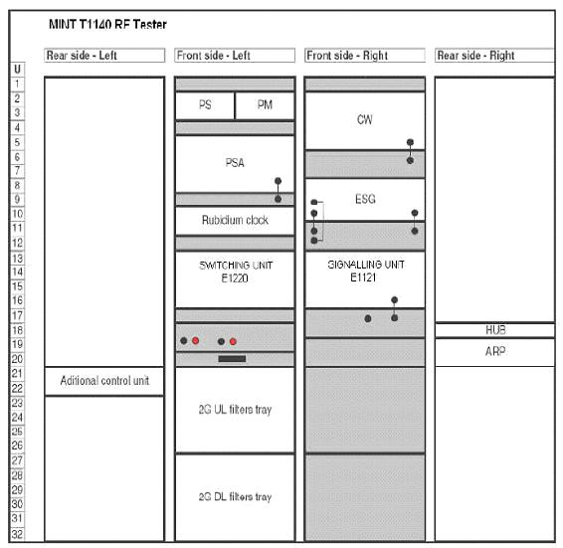
Fig. 1 MINT Structure

  - Spectrum Analyser: Agilent E4445A PSA
  - Out-of-band (IG-CW): Agilent E8257D
  - In-band generator: Agilent ESG 4438C
  - Power Meter: Agilent E4419B
  - Power Supply (DC): Agilent 66311B
  - Switching Units: E1220/E1223
  - Advanced Filter Modules: E1221/E1222
  - Signalling Unit: E1121
  - GPS Controlled Frequency Standard: Fluke 910R
  - DARP Generator E1410 : Generates interference I/Q signals in Base Band.
  - System Controller: PC
The Control Unit provides control for the whole system through the control
buses. It is located in the control PC, where the MINT T1140 RF Tester Software is installed.
A Spectrum Analyser / Vector Analyser captures the received signal in order to be demodulated and processed. The SA/VA performs the power, timing, phase and frequency measurements.
There are two Interferer Generators in the test platform, one of them is an Outof-
band Continuous Wave generator (IG-CW) used for the blocking and intermodulation test cases.
The second Interferer Generator is used to produce GSM In-band interferer signal.
The Switching Unit provides all the connections between the UE and the measuring equipment. It is configured as required by the Test Cases or Calibration routines.
The Advanced filter modules completes the Switching Unit implementation.There are 3 different units:
· Advanced Filter Control Unit controls both filter trays (Advanced Filter Unit UL and DL) to provide interconnection for the control of the Notch, Band Reject and High pass filters.
· Advanced Filter Unit Uplink consists of a set of notch filters required for
some Test Cases.
· Advanced Filter Unit Downlink consists of a set of Reject band filters required for blocking Test Cases and a High pass filter for spurious measurements.
The reference frequency (10 MHz) coming from the Rubidium Clock is distributed to the rest of instruments in order to keep the system synchronised. A Power Meter is used for the calibration routines. It performs power measurements required for the process of loss calculations from the different RF paths and cables in the system.
The DC power supply for feeding the UE is also controlled by the system.
A signalling unit (SU) manufactured by Centro de Tecnología de las Comunicaciones S.A. is used to simulate a GSM base station. The Signalling Unit establishes the links with the UE and supports requested signalling to control UE operation modes during the Test Case executions. It also supports BER, FER and BLER measurements.
The Fading Generator included in the Signalling Unit is in charge of applying a defined fading profile for some Test Cases when an unwanted signal is requested from 3GPP TS 51.010-1 (the wanted signal is faded directly in baseband inside the SU).
DARP Generator produces interference I/Q signals in baseband and needs the
Interference Generator IG-GSM to be modulated to RF.
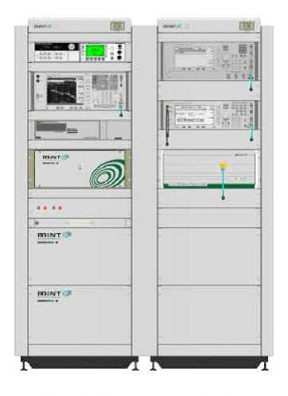
Fig. 2 MINT T1140 RF Tester

- Test coverage
- 3GPP TS 51.010-1
  - Section 12 : Tranceiver(excluding radiated spurious emission tests)
  - Section 13 : Transmitter
  - Section 14 : Receiver
  - Section 21 : Received Signal Measurements

