SAT+8 for GSM/GPRS Protocol Testing

1. System Configuration
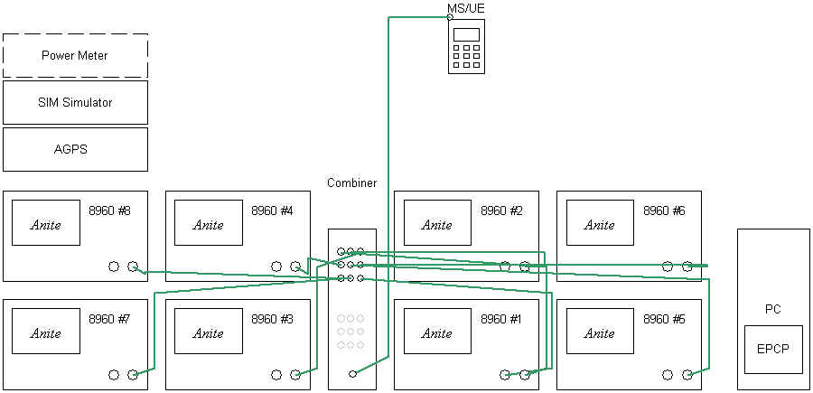
Fig. 1 Anite SAT+8 Structure

- 8960 : Base Station Simulator
- Control PC
- RF Combiner

The Anite SAT for mobile stations consists of a PC system and software connected to
a digital radio sub-system. The system allows you to run type-approval test cases.
The test cases can be combined to form test campaigns, each campaign being a
convenient way of repeating a set of tests.

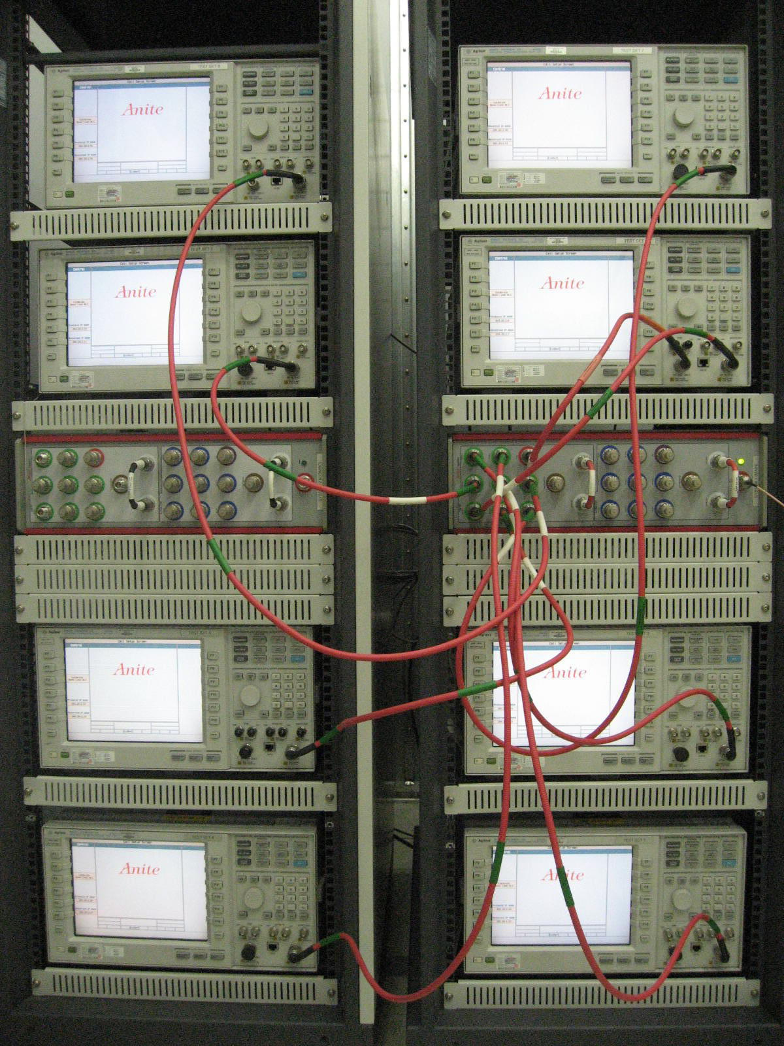
Fig. 2 Anite SAT+8

2. Test Coverage
- 3GPP TS 51.010-1
  - Section 11 : General tests
  - Section 15 : Timing Advance and Absolute Delay
  - Section 17 : Access Times during Handover
  - Section 18 : Temporary Reception Gaps
  - Section 19 : Channel Release after Unrecoverable Errors
  - Section 20 : Cell Selection and Reselection
  - Section 21 : Received Signal Strength
  - Section 22 : Transmit Power Control Timing and Confirmation
  - Section 25 : GSM Layer 2
  - Section 26 : GSM Layer 3
  - Section 28 : Autocalling Restrictions
  - Section 29 : Bearer Services
  - Section 31 : Supplementary Services
  - Section 32 : Speech Transcoding Functions
  - Section 33 : Mobile Station Features
  - Section 34 : Short Message Service
  - Section 41 : GPRS Paging, TBF Establishment/Release and DCCH related Procedures
  - Section 42 : GPRS Medium Access Control
  - Section 43 : GPRS Radio Link Control
  - Section 44 : GPRS Mobility Management
  - Section 45 : GPRS Session Management Procedures
  - Section 46 : GPRS LLC and SNDCP

