Shock Testing System

1. Overview

This testing system is to ensure that the EUT shock stability test. Shock stability is the ability of the EUT to maintain specified mechanical and electrical performance after being shocked. Required test conditions are specified in the TIA/EIA IS-98D&E (CDMA) and TIA/EIA-690 (AMPS) industry standards.
Here below, the general description and operation guidance of the TTA’s current Shock Testing System will be introduced.

2. System Component and Console SW Lists

* Component
- Shock Testing System Model MDST-300
(Refer to system reference manual for specific details)

* Console Software
- SHOCK MANAGER Model: SMS-400/400M Ver1.1

3. System Appearance
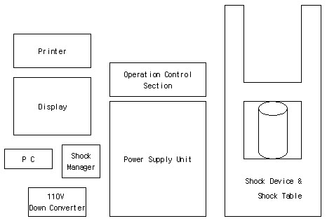
Figure 1. Shock testing system name of parts

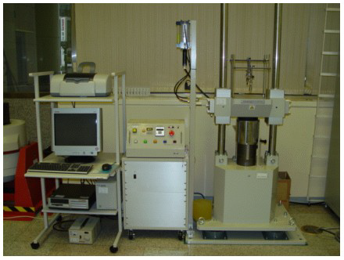
Figure 2. Shock testing system appearance

