Temperature and Humidity Testing System

1. Overview
This testing system is to ensure that the EUT operates under a variety of environmental temperature and humidity conditions. The ambient temperature is the average temperature of the air surrounding the EUT. The manufacturer is to specify the temperature range over which the equipment is to operate. The humidity denotes the relative humidity at which the EUT will operate with the specified performance. Test conditions required are specified in the TIA/EIA IS-98D & E (CDMA) and TIA/EIA-690 (AMPS) industry standards.
Here below, the general description and operation guidance of the TTA’s current Temperature and Humidity Testing System will be introduced.

2. System Component and Console SW Lists

* Component
-ETAC Temperature and Humidity Chamber HIFLEX V+2
-YOKOGAWA Electric Corporation SR1000-N Recorder
-ETAC HIFLEX Temperature and Humidity Chamber GP-IB INTERFACE
(P-Specification)

* Console Software
- Not included

3. System Appearance

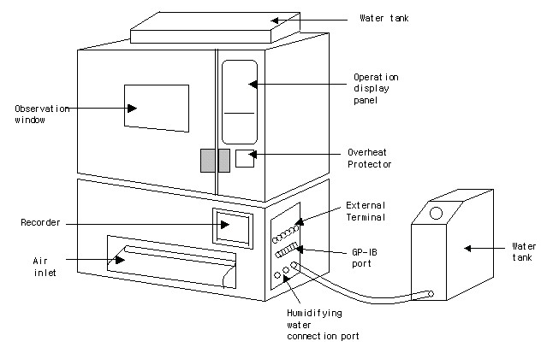

Figure 1 Temperature and humidity testing system name of parts

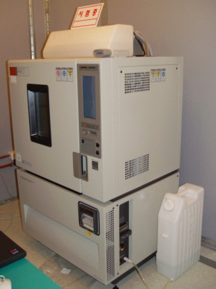

Figure 2 Temperature and humidity testing system appearance

