TS8950G for GSM/GPRS/EGPRS RF testing

- System Configuration

NGSM32
SMIQ03B
SMP02
ASCU850
ASCU900
ASCU1800
ASCU1900
CS-HUB
SMIQ03B
FSU26
SSCU-GW
CRTU-S
NRVD
ABFS
PSL3
CS-RUB5

Fig. 1 TS8950G Structure

  - NGSM32 : DC Power Supply
  - SMIQ03B : Vector Signal Generator
  - SMP02 : Simulation of high power and outer band CW interferer
  - ASCU850 : Advanced Signal Switching and Conditioning Unit for GSM850
  - ASCU900 : Advanced Signal Switching and Conditioning Unit for GSM900
  - ASCU1800 : Advanced Signal Switching and Conditioning Unit for GS1800
  - ASCU1900 : Advanced Signal Switching and Conditioning Unit for GS1900
  - CS-HUB : LAN Connection
  - FSU26 : Spectrum Analyzer
  - SSCU-GW : Signal Switching and Conditioning Unit
  - CRTU-S : Base Station Simulator
  - NRVD : Power Meter
  - ABFS : Fading Simulator
  - PSL3 : System Controller(Control PC)
  - CS-RUB5 : Rubidium Frequency Standard and Reference Distribution

The test system supports numerous RF test cases based on either the transceiver, transmitter or receiver test method which are defined by the 3GPP test specification. These test methods can be executed with a well-defined set of parameters compliant to the relevant sections of the 3GPP test specification, but also with freely selectable parameters defining customer specific R&D test scenarios.
The test system is designed to perform RF tests for GSM, GPRS, and (EGPRS) mobile phones. The heart of the system is the signalling and protocol unit CRTU-S in combination with the baseband fading simulator ABFS.
The RF output of the mobile phone is analysed by means of the build in spectrum analyser.
A rubidium frequency standard is used to synchronise all devices.

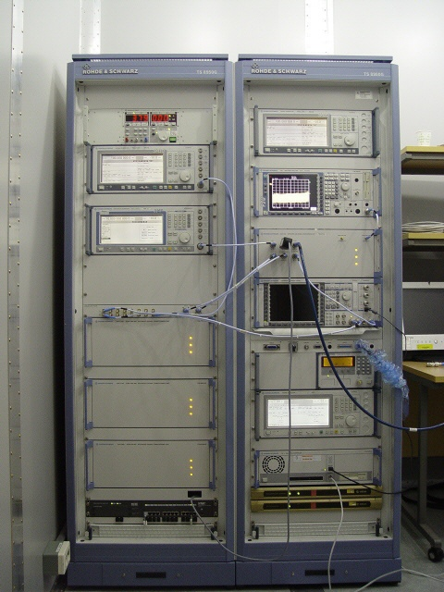

Fig. 2 Rohde & Schwarz TS8950G .

- Test coverage
- 3GPP TS 51.010-1
  - Section 12 : Tranceiver(excluding radiated spurious emission tests)
  - Section 13 : Transmitter
  - Section 14 : Receiver
  - Section 21 : Received Signal Measurements
  - Section 22 : Transmit Power Control Timing and Confirmation

