UPL16 with CMU200 for GSM/GPRS/WCDMA Audio testing

- System Configuration

Fig. 1 Structure of UPL16 with CMU 200

  - CMU200 : Call Generator
  - UPL16 : Audio Analyzer

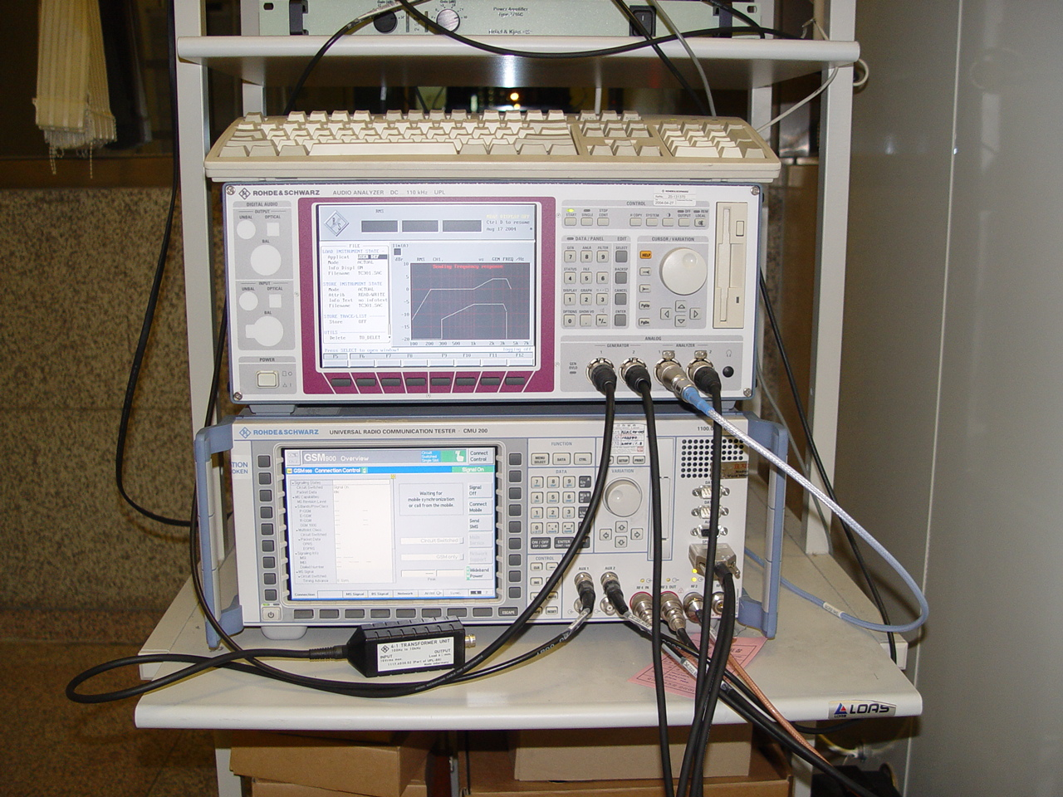
Fig. 2 Rohde & Schwarz UPL16 with CMU200

UPL16 is especially designed for acoustic tests of GSM Mobiles. Therefore the instrument is equipped with the Digital Audio Interface DAI, artificial voice generator and necessary software routines. Together with CMU200 and completed with an artificial mouth/ear combination, UPL16 provides a complete system handling the acoustic test cases according to 3GPP TS 51.010-1, section 30, up to release 99. For WCDMA handsets, 3GPP TS 26.132 is applicable.

- Test coverage
- 3GPP TS 51.010-1
  - Section 30 : Speech(Audio) Teleservices

- 3GPP TS 26.132
  - Speech and video telephony terminal acoustic test specification

