Vibration Test

1 Overview

This testing system is used for the EUT vibration stability test. Vibration stability is the ability of the EUT to maintain specified mechanical and electrical performance during and after being vibrated. Required test conditions are specified in the TIA/EIA IS-98D&E (CDMA) and TIA/EIA-690 (AMPS) industry standards.
Here below, the general description and operation guidance of the TTA’s current Vibration Testing System will be introduced.

2. System Configuration

* Component
- LDS V790 Vibration Generator
- LDS Digital Sine controller DSC4-CE
- LDS HPAK SERIES AMPLIFIERS

3. System Appearance

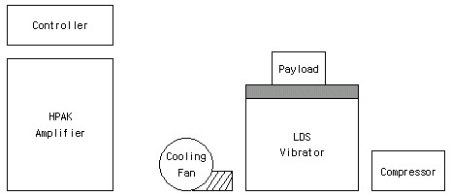

Figure 1. Vibration testing system name of parts

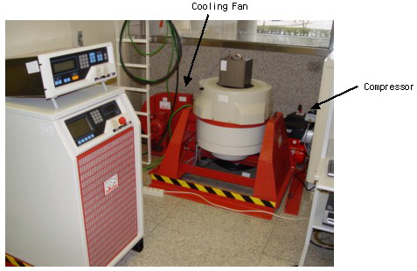
Figure 2. Vibration testing system appearance

